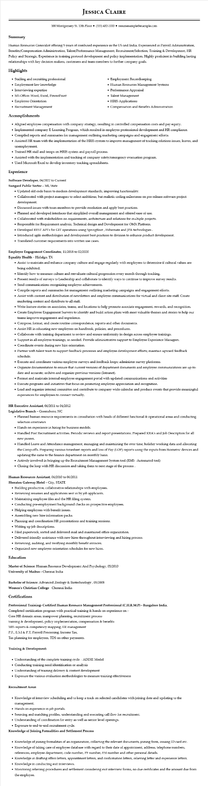
JESSICA CLAIRE
100 Montgomery St. 10th Floor⚫ (555) 432-1000⚫ resumesample@example.com
Summary
Human Resources Generalist offering 5 years of combined experience in the US and India. Experienced in Payroll Administration, Benefits/Compensation Administration, Talent/Performance Management, Recruitment/Selection, Training & Development, HR Policy and Strategic. Experience in training protocol development and policy implementation. Highly proficient in building lasting relationships with key decision makers, customers and team members to further company goals.
Highlights
• Staffing and recruiting professional
• Employment law knowledge
• Interviewing expertise
• MS Office: Word, Excel, PowerPoint
• Employee Orientation
• Employment Recordkeeping
• Human Resources Management Systems
• Performance Appraisal
• Talent Management
• HRIS Applications
• Compensation and Benefits Administration
• Recruitment Management
Accomplishments
• Aligned employee compensation with company strategy, resulting in controlled compensation costs and pay equity.
• Implemented company E-Learning Program, which resulted in employee professional development and HR compliance.
• Compiled reports and summaries for management outlining marketing campaigns and engagement efforts.
• Assisted HR team with the implementation of the HRIS system to improve management of tracking relations issues, leaves, and unemployment.
• Trained HR staff and temps on HRIS system and payroll process.
• Assisted with the implementation and tracking of company safety/emergency evacuation program.
• Used Microsoft Excel to develop inventory tracking spreadsheets.
Experience
Software Developer, 04/2022 to Current
Sungard Public Sector - MI, State
•
Updated old code bases to modern development standards, improving functionality.
• Collaborated with project managers to select ambitious, but realistic coding milestones on pre-release software project development.
• Discussed issues with team members to provide resolution and apply best practices.
• Planned and developed interfaces that simplified overall management and offered ease of use.
• Collaborated with stakeholders on requirements, architecture and solutions for multiple projects.
• Responsible for Requirement analysis, Technical design and Development for OMX Platform.
• Developed REST API's for GIT operations using SpringBoot, Hibernate and JPA technologies.
• Introduced agile methodologies and development best practices to division to enhance product development.
• Translated customer requirements into written use cases.
Employee Engagement Coordinator, 11/2018 to 02/2020
Equality Health – Hidalgo, TX
• Assist to maintain and enhance company culture and engage regularly with employees to determine if cultural values are being exhibited.
• Identify how to measure culture and reevaluate cultural progression every month through tracking.
• Present results of surveys to Leadership and collaborate to identify ways to continue to improve survey results.
• Send communications recognizing employee achievements.
• Compile reports and summaries for management outlining marketing campaigns and engagement efforts.
• Assist with content and distribution of newsletters and employee communications for virtual and client site staff. Create marketing content and distribute to all staff.
• Write feature stories on associates, teams, and locations to help promote associate engagement, rewards, and recognition.
• Create Employee Engagement Surveys to identify and build action plans with most valuable themes and stories to help our teams improve engagement and experience.
• Compose, format, and create routine correspondence, reports and other documents.
• Assist HR in educating new employees on handbook, policies, and procedures.
• Collaborate with training department to review and ensure uniformity in design across employee trainings.
•
Support in all employee trainings, as needed. Provide administrative support to Employee Experience Managers.
• Coordinate events during new hire orientation.
• Partner with talent team to support feedback processes and employee development efforts; maintain upward feedback schedule.
• Execute and coordinate various employee surveys and feedback loops; administer survey platforms.
•
Organize documentation to ensure that current versions of department documents and employee communications are up-to- date and accurate; archive and organize previous versions (Intranet).
• Format and maintain internal employee engagement portal with updated communications and activities
• Execute programs and initiatives that focus on promoting employee appreciation and recognition.
• Lead and organize internal committee and contribute to company-wide calendar and produce events that provide meaningful experiences for employees to connect virtually.
HR Executive Assistant, 06/2011 to 04/2012
Legislative Branch - Greensboro, NC
• Planned human resource requirements in consultation with heads of different functional & operational areas and conducting selection interviews
• Hands on experience in hiring for business models.
• Handled Post Recruitment activities. Periodic reviews and report presentations. Prepared KRA's and Job Description for all new joiners.
• Handled Leave and Attendance management, managing and maintaining the over time, holiday working data and allocating the Comp-offs. Preparing various timesheet reports and loss of Pay (LOP) reports using the inputs from Biometric devices and updating the same to the finance department on monthly basis.
• Actively involved in bringing up the Recruitment Management System tool (RMS-Automated tool)
• Closing the loop with HR discussion and taking them to next stage of the process.
Human Resources Assistant, 06/2010 to 06/2011
Sheraton Gateway Hotel - City, STATE
• Building productive, collaborative relationships with employees.
• Reviewing resumes and applications sent in by job applicants.
• Maintaining employee files and the HR filing system.
• Conducting pre-employment background checks on prospective employees.
• Helping employees with benefit issues.
• Assembling new hire information packs.
• Planning and coordination HR presentations and training sessions.
• Writing up job descriptions.
• Filed paperwork, sorted and delivered mail and maintained office organization.
• Delivered friendly assistance with new hires throughout interviewing and hiring process.
• Reviewing, auditing, and verifying monthly benefit invoices.
• Organized new employee orientation schedules for new hires.
Education
Master of Science: Human Resource Development And Psychology, 05/2010
University of Madras - Chennai India
Bachelor of Science: Advanced Zoology & Biotechnology, 05/2008
Women's Christian College - Chennai India
Certifications
Professional Training- Certified Human Resource Management Professional (C.H.R.M.P) - Bangalore India.
Completed certification program with practical training & hands on experience on :-
Core HR domain areas, manpower planning, recruitment process
training & development, policy implementation, compensation & benefits
MIS reports & competency mapping, ER management
P.F., E.S.I & P.T, Payroll Processing, Income Tax,
Tax planning for employees, TDS on other payments.
Training & Development:
• Understanding of the complete training cycle - ADDIE Model
• Conducting training need identification or analysis
• Understanding of training delivery & content development
• Exposure the various evaluation methodologies to measure training effectiveness
Recruitment Areas
• Knowledge of interview scheduling and to keep a track on selected candidates with joining date and updating to the
management.
• Hands on experience in job portals.
• Sourcing and matching profiles, understanding and executing call flow for recruitment.
• Understanding of coordination for entry as well as senior level openings.
• Exposure to end-to-end recruitment cycle.
Knowledge of Joining Formalities and Settlement Process
• Knowledge of joining formalities of an organization, collecting the relevant documents, joining form, issuing ID card etc.
• Knowledge of taking care of employee database with regard to their date of appointment, address, telephone numbers, references, employee department, code number, PF number, ESI number and other personal details.
• Knowledge in drafting offers letters, appointment letters, and confirmation letters, relieving letter and experience letters.
• Knowledge in conducting exit interviews.
• Monitoring relieving procedures and settlement considering exit interview forms, no due certificates and the amount due from
the employee.

